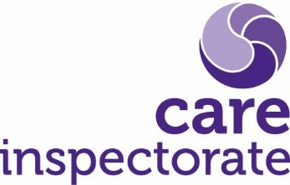

Example questionnaire for visiting professionals support and services

The questions below are based on the Care Inspectorate’s quality framework for support services, which sets out their expectations about how care services should improve outcomes for people. The headings are from the key areas in the framework.
We are always keen to improve, and your honest feedback is very important to us.
Please tell us how we are doing and where we can make improvements, even if you feel these are only small things. If you have feedback not covered by the questions below, please use the box at the end of the form to tell us about this. Alternatively, you can arrange to speak with a manager.

1 - I see staff treating people with dignity and respect.

Unsatisfactory | Weak | Adequate | Good | Very good | Excellent

2 – Staff follow professional advice and treatment plans appropriately.

Unsatisfactory | Weak | Adequate | Good | Very good | Excellent

3 – Staff appear confident and know what they are doing.

Unsatisfactory | Weak | Adequate | Good | Very good | Excellent

4 – Staff communicate relevant information timeously and effectively.

Unsatisfactory | Weak | Adequate | Good | Very good | Excellent

5 - I see staff following infection prevention and control standards appropriately, where required.

Unsatisfactory | Weak | Adequate | Good | Very good | Excellent

If there are specific areas you think we could improve on, please provide some detail below.

If there is anything else you’d like to add, please use the box below.

